Happy Pet Products Ltd

Code | Product
82300 | Ceramic ES Lamp Fixture
82301 | Reflector Dome Clamp Lamp (14cm)
82305 | T8 Fluorescent Ballast (15W)

To help identify the plugs which need replacing, please refer to the images here which highlight the differences.

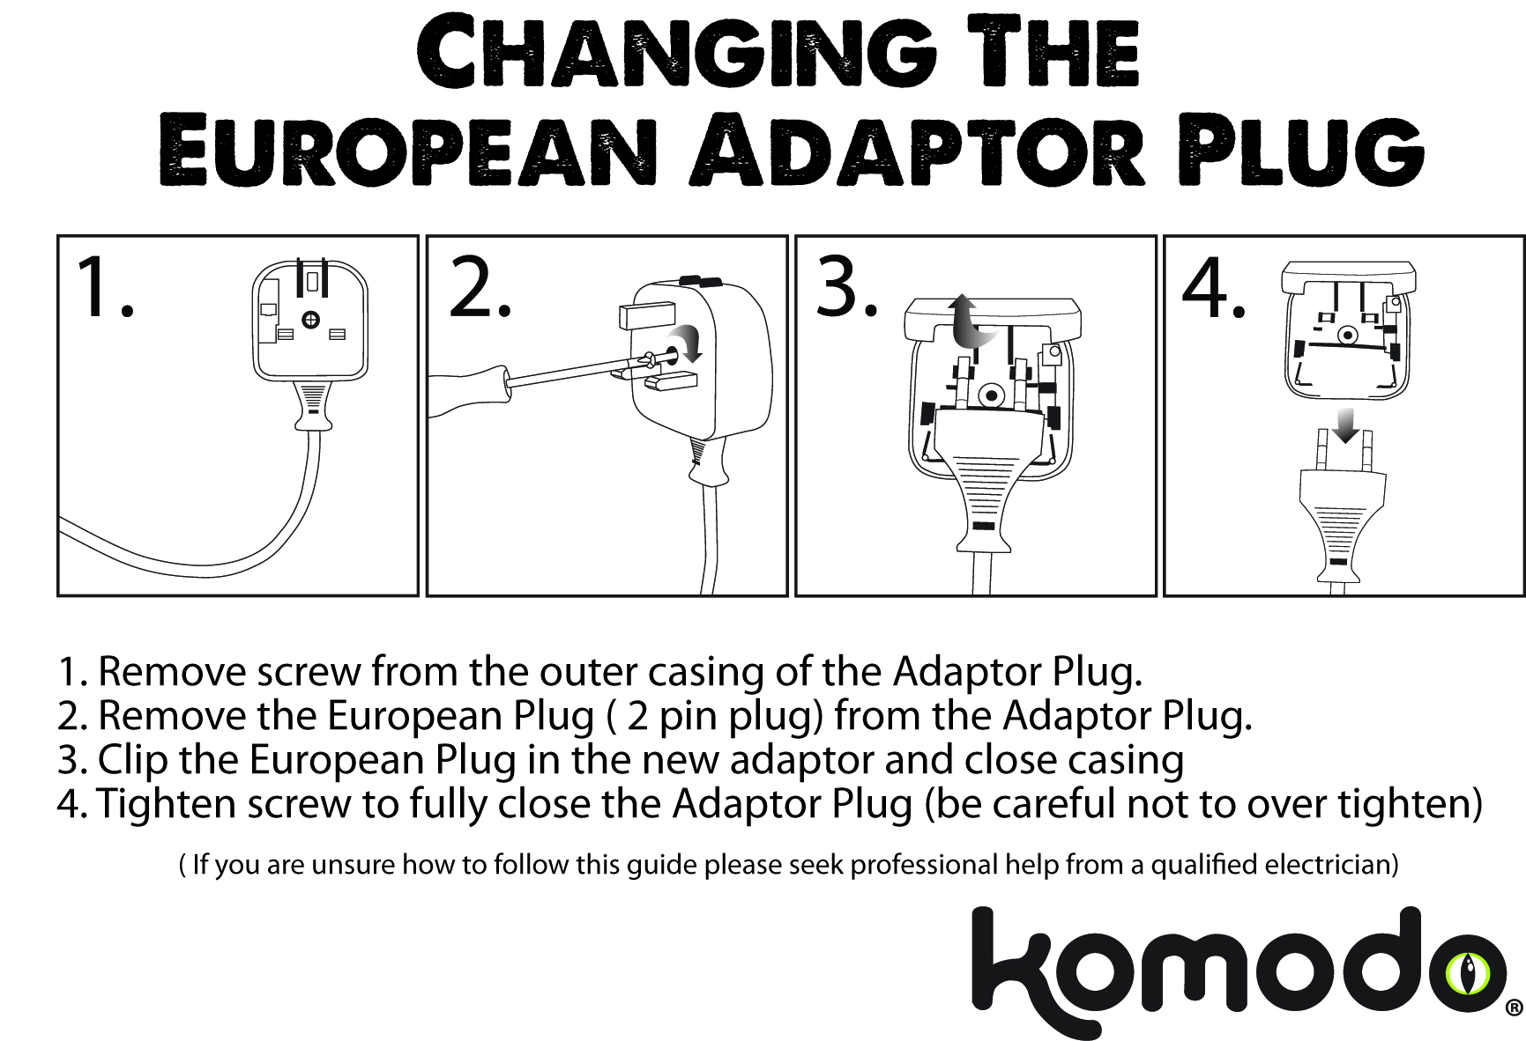

Please follow these instructions to change the converter plug.

